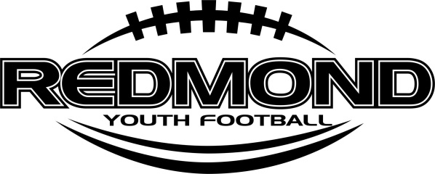
Mission and Values

The mission of Redmond Youth Football is to provide a safe, fun learning environment for the youth of our community while developing the basic fundamentals for the game of football.
Thank you for joining Redmond Youth Football. We routinely have over 200 players registered each year. This will be RYF’s 9th season. We take direction from both high schools and have tremendous support of RHS Coach Nathan Stanley and RVHS Coach Andy Codding. Our league is simply not possible without our volunteer coach’s, our parents, our referees and our kids. We need everyone’s help to be successful. We would like you to please review the following values and code of conduct.
Athlete's Code
I Will:
- Have fun!
- Be a good sport (win or lose), be honest and fair.
- Learn the value of commitment to the team; sportsmanship, ethical conduct, and fair play.
- Show courtesy and respect to my teammates, opponents, coaches and officials.
- Know that athletic contests are educational and learning experiences.
- Give complete attention to the instructions of my coaches and league officials.
I Will Not:
- Use profanity, talk "trash", or taunt others before, during, or after any game.
- Display any unsportsmanlike behavior.
- Criticize my teammates or players from other teams.
- Act in any way that may incite spectators.

Parents/Spectators Code of Conduct
As a parent or spectator, I will:
- Support the coaches and players and help teach the value of commitment to the team, sportsmanship, ethical conduct, and fair play.
- Support my child's team and help my child make athletic contests a positive educational experience.
- Direct constructive criticism of my child's team program to the head coach and/or association officials at an appropriate time. I will work toward a positive result for all concerned.
- Accept decisions of the game officials (including coaches) on the field as being fair and called to the best ability of said officials. The officials are in charge of all games; their decisions are final.
- Exhibit exemplary sportsmanship at all times.
- Emphasize that good athletes strive to be good students that are physically and mentally alert.
- Abstain from being under the influence of or in possession of and/or drinking alcoholic beverages and the possession or use of any illegal substance on both the game and practice fields.
- Stay behind the designated spectator line during a game.
As a parent or spectator, I will not:
- Interfere/interrupt the coaching staff during games or practices.
- Criticize officials or coaches, direct abuse or profane language toward them, or otherwise subvert their authority.
- Criticize an opposing team, its players, coaches, or spectators by word of mouth, by gesture, or by deliberately inciting unsportsmanlike behavior.

